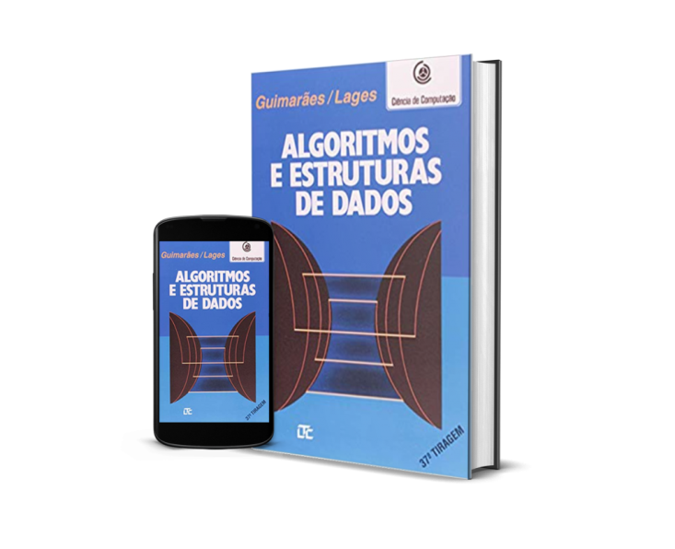

Onde comprar:

https://www.amazon.com.br/Algoritmos-Estruturas-Dados-Angelo-Guimar%C3%A3es/dp/8521603789

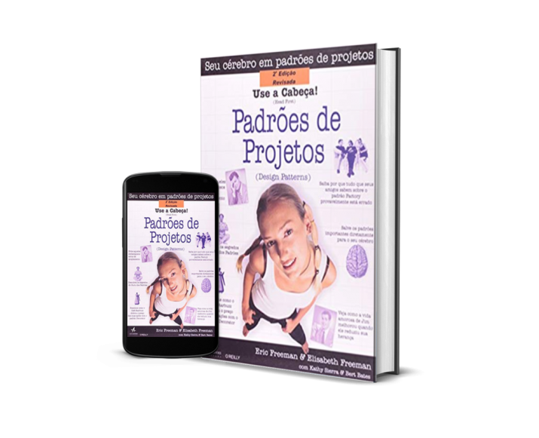

Onde comprar: https://www.amazon.com.br/Cabe%C3%A7a-Padr%C3%B5es-Projetos-Eric-Freeman/dp/8576081741/ref=sr_1_1?__mk_pt_BR=%C3%85M%C3%85%C5%BD%C3%95%C3%91&dchild=1&keywords=Use+a+Cabe%C3%A7a%21+Padr%C3%B5es+de+Projetos&qid=1635293185&s=books&sr=1-1&ufe=app_do%3Aamzn1.fos.6121c6c4-c969-43ae-92f7-cc248fc6181d

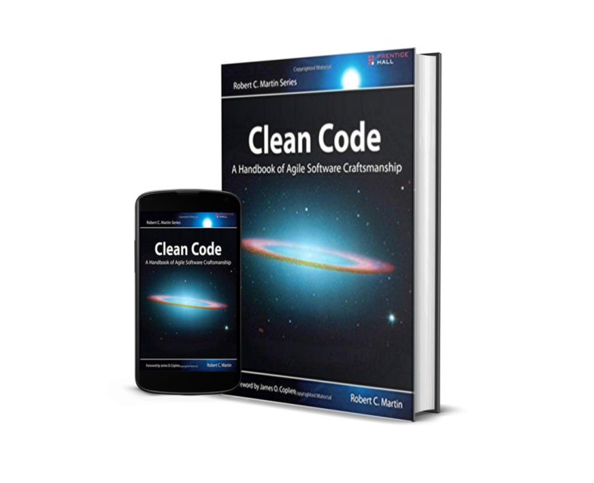

Onde Comprar:

https://www.amazon.com.br/C%C3%B3digo-limpo-Robert-C-Martin/dp/8576082675/ref=sr_1_1?__mk_pt_BR=%C3%85M%C3%85%C5%BD%C3%95%C3%91&crid=3FIKQTV1NT20P&dchild=1&keywords=codigo+limpo+livro&qid=1635293223&s=books&sprefix=codi%2Cstripbooks%2C353&sr=1-1&ufe=app_do%3Aamzn1.fos.6d798eae-cadf-45de-946a-f477d47705b9

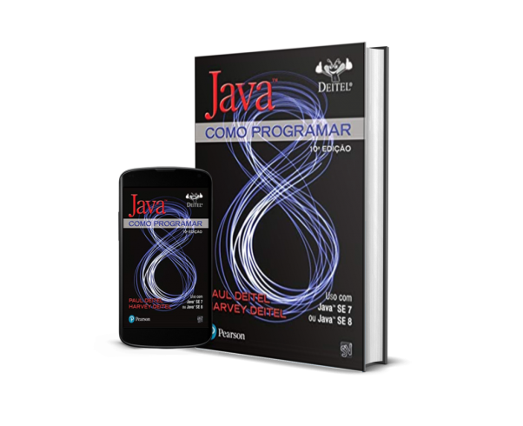

Onde Comprar:

https://www.amazon.com.br/Java%C2%AE-como-programar-Paul-Deitel/dp/8543004799/ref=sr_1_1?__mk_pt_BR=%C3%85M%C3%85%C5%BD%C3%95%C3%91&crid=1DY4QTBLLRUCH&dchild=1&keywords=java+como+programar&qid=1635293266&s=books&sprefix=java+como%2Cstripbooks%2C473&sr=1-1&ufe=app_do%3Aamzn1.fos.25548f35-0de7-44b3-b28e-0f56f3f96147

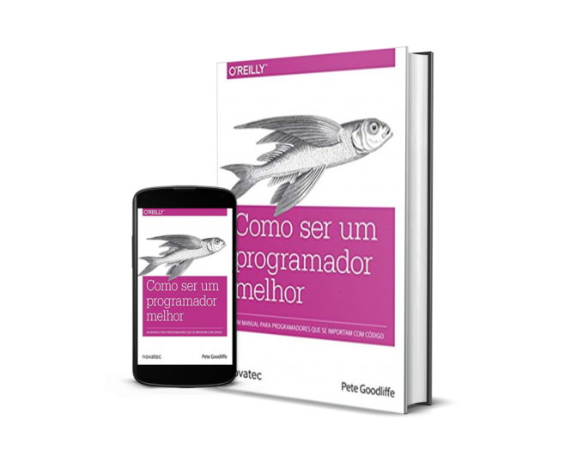

Onde comprar: <https://www.amazon.com.br/Como-Ser-Um-Programador-Melhor/dp/8575224158/ref=sr_1_1?__mk_pt_BR=%C3%85M%C3%85%C5%BD%C3%95%C3%91&dchild=1&keywords=Como+Ser+Um+Programador+Melhor&qid=1635293314&s=books&sr=1-1&ufe=app_do%3Aamzn1.fos.6d798eae-cadf-45de-946a-f477d47705b9>

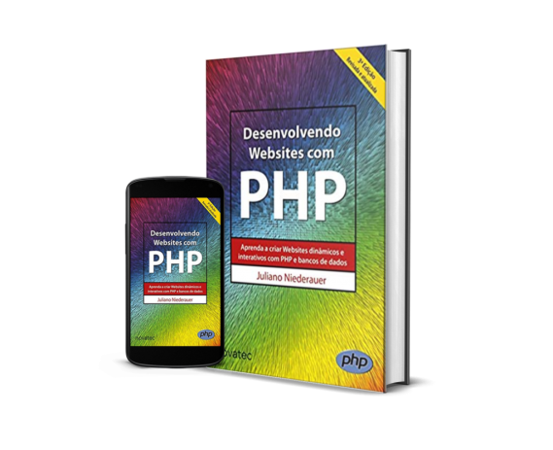

Onde Comprar: <https://www.amazon.com.br/Desenvolvendo-Websites-com-PHP-Interativos/dp/8575225340/ref=sr_1_1?__mk_pt_BR=%C3%85M%C3%85%C5%BD%C3%95%C3%91&dchild=1&keywords=Desenvolvendo+Websites+com+PHP&qid=1635293458&s=books&sr=1-1>

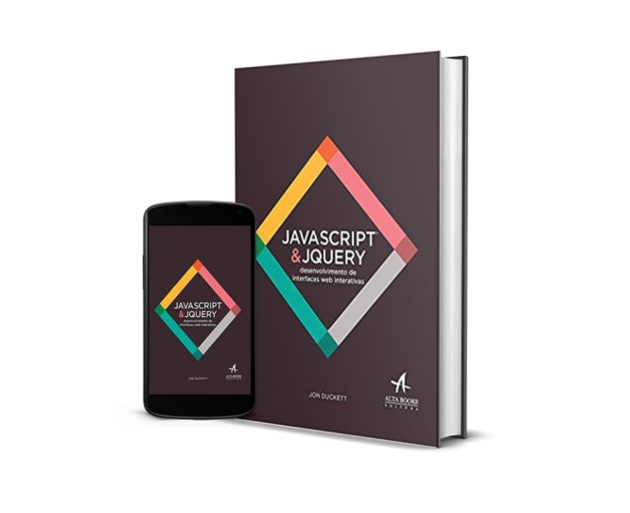

Onde comprar: <https://www.amazon.com.br/Javascript-Jquery-desenvolvimento-Jon-Duckett/dp/8576089459/ref=sr_1_1?__mk_pt_BR=%C3%85M%C3%85%C5%BD%C3%95%C3%91&dchild=1&keywords=Javascript+e+Jquery+desenvolvimento&qid=1635293584&s=books&sr=1-1&ufe=app_do%3Aamzn1.fos.4bb5663b-6f7d-4772-84fa-7c7f565ec65b>

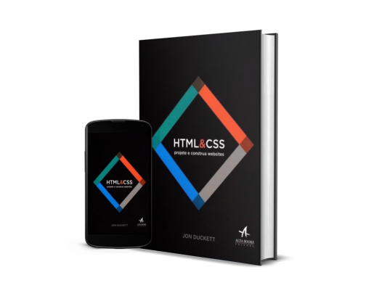

Onde Comprar:

<https://www.amazon.com.br/HTML-CSS-projete-construa-Websites/dp/8576089394/ref=sr_1_1?__mk_pt_BR=%C3%85M%C3%85%C5%BD%C3%95%C3%91&dchild=1&keywords=HTML+e+CSS+projete+e+construa+Websites&qid=1635293754&s=books&sr=1-1&ufe=app_do%3Aamzn1.fos.6a09f7ec-d911-4889-ad70-de8dd83c8a74>

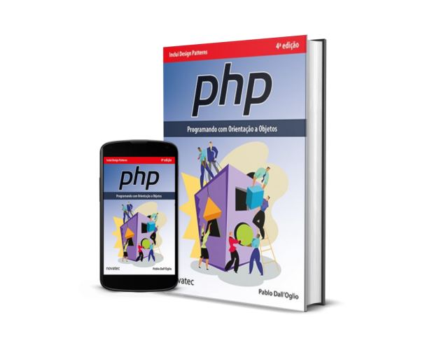

Onde Comprar:

<https://www.amazon.com.br/PHP-Programando-com-Orienta%C3%A7%C3%A3o-Objetos-ebook/dp/B07G9PQJQR/ref=sr_1_1?__mk_pt_BR=%C3%85M%C3%85%C5%BD%C3%95%C3%91&dchild=1&keywords=Php+Programando+com+Orienta%C3%A7%C3%A3o+a+Objetos&qid=1635293855&s=books&sr=1-1>

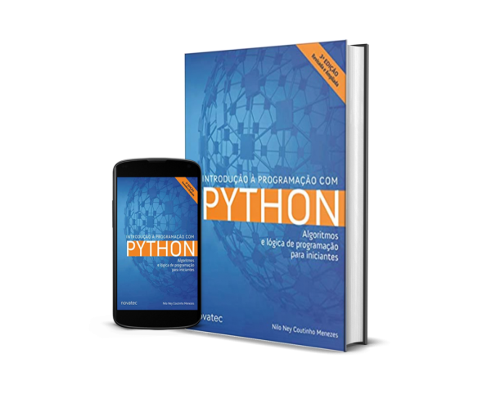

Onde comprar:

<https://www.amazon.com.br/Introdu%C3%A7%C3%A3o-Programa%C3%A7%C3%A3o-com-Python-Algoritmos/dp/8575227181/ref=sr_1_1?__mk_pt_BR=%C3%85M%C3%85%C5%BD%C3%95%C3%91&dchild=1&keywords=Introdu%C3%A7%C3%A3o+%C3%A0+Programa%C3%A7%C3%A3o+com+Python&qid=1635293997&s=books&sr=1-1>